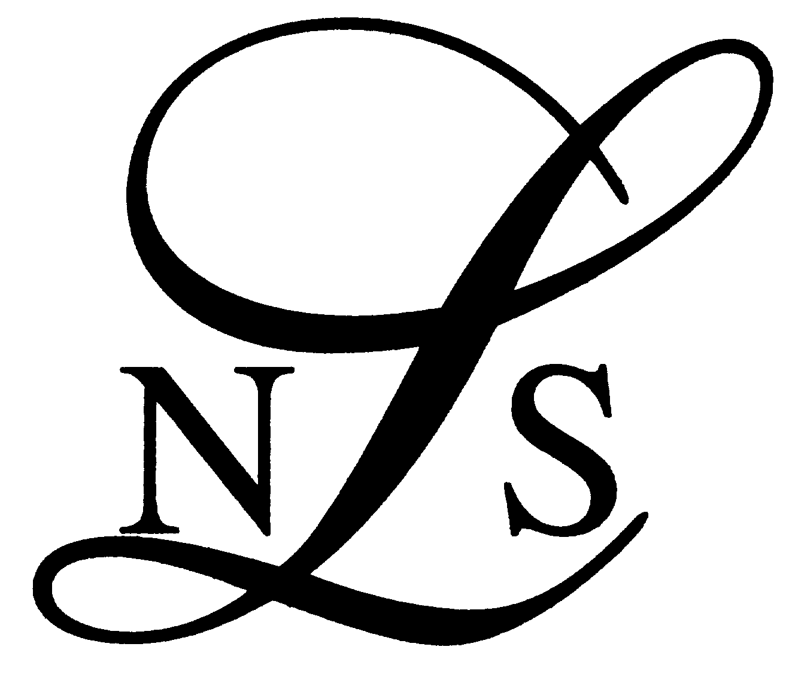

Associate Membership Application
(Please Print Clearly)

Title………………………………………………………………………………..

Full Name………………………………………………………………………….

Firms address……… ………………………………………………

……………………………………………………………………………………..

……………………………………………………………………………………..

Tel. No ………..……………Mobile Number……………………………………

E-mail: ……………………..Private Email;……………………………………..

Does your firm have a website Yes/No
If yes, please provide your website address http://........................................

Please indicate your qualification (delete as appropriate):

Barrister/Legal Executive/Licensed Conveyancer/Patent Attorney/Notary

Areas of specialism……………………………………………………………………

……………………………………………………………………………………..

Do you undertake Legal Aid Agency work yes/no if yes in which areas…………………..

………………………………………………………………………………………....

Signature of applicant…………………………………………………………………

Nominated by ……………………………………………………Signature

Please print name………………………………………………………………….

Name of Firm ……………………………………………………………………

Seconded by ………………………………………………………Signature

Please print name………………………………………………………………….

Name of Firm ……………………………………………………………………

Both signatures to this nomination must be members of the Society

Once fully completed please return this form to:

Carolyn Coles
Society Manager
Northamptonshire Law Society
The Gatehouse
Stable Lane
Pitsford
Northampton NN6 9NG

Or Mail to sec.nls@outlook.com
Tel: 01604 881154, or mobile 07543 662572 for further information.

For society use only

Before council ……………………………….…………………….

Letter of acceptance sent…………………………………………………………

